What do you suggest for photo sharing? Flickr?

**2020**

“A Trip Down Memory Lane” at Paul & Eddie’s: February 29

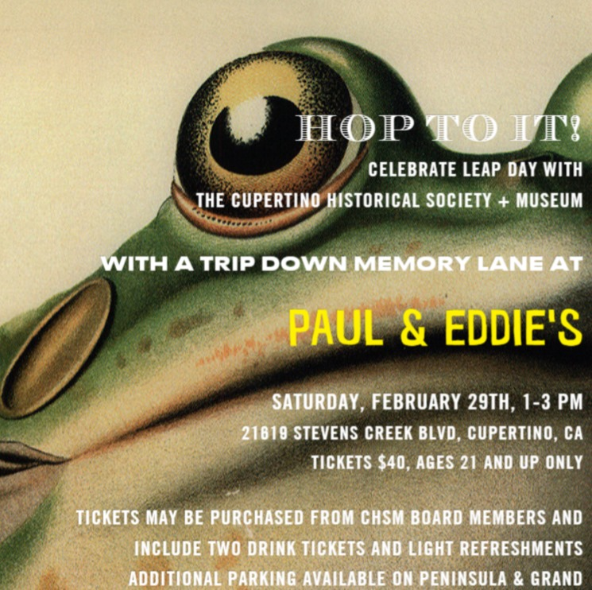

2019

Board/Donor Holiday Party 2019: December 4

Museum Open House during the Quinlan Tree Lighting: December 6

Volunteer Appreciation Event: December 8

Museum Open House During Bay Area Diwali Festival: October 12

Museum Open House During Silicon Valley Fall Festival: September 14

Museum Open House During Kids Fun Festival: August 10

Chinese Valentine's Day Celebration with Author Crystal Tai: August 7

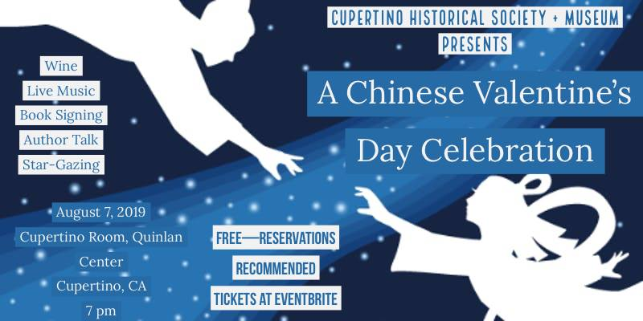

Cupertino Chamber of Commerce Summer Business Social: July 11

“A Sip of History” Annual BBQ: June 30

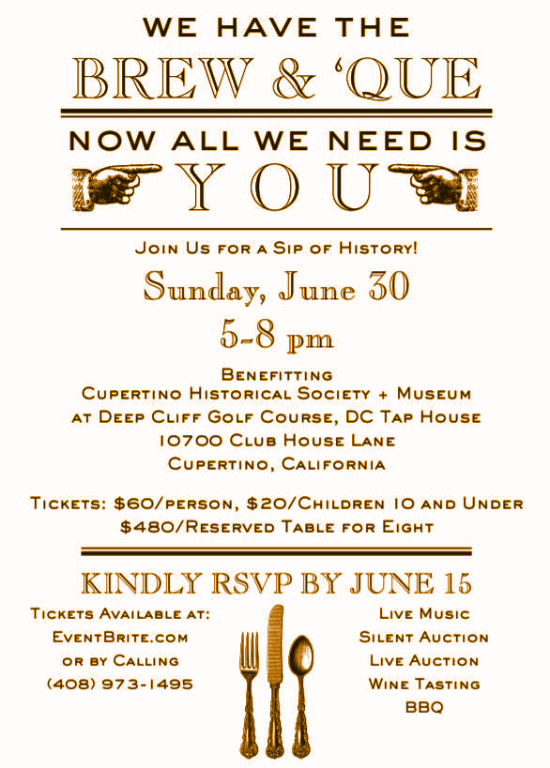

“Homage to the Information Technology Revolution” Exhibit Opening: June 19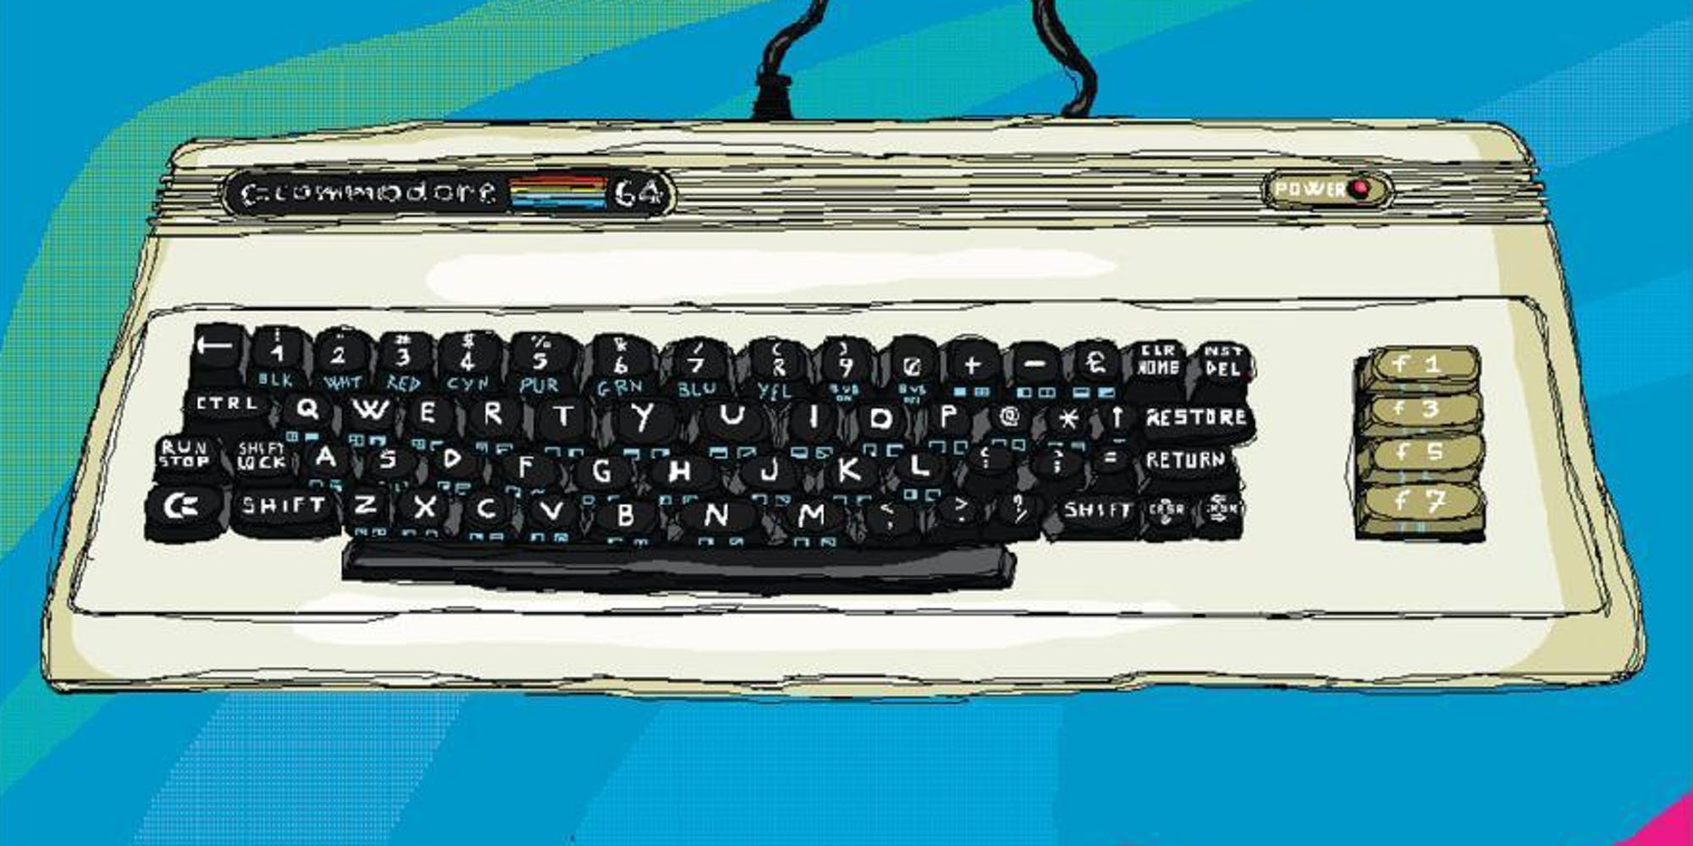

150th Anniversary Trans-Continental Railroad Celebration: May 17

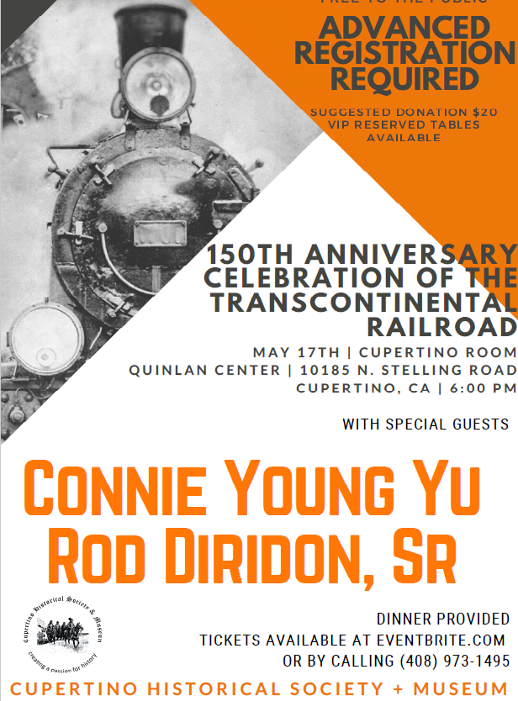

Museum Open House During the Cherry Blossom Festival: April 28

Museum Open House During Cupertino Holi: April 7

Museum Open House and Bunny Craft for Kids: March 23